Question 3

Explore traceroute/tracert for different websites eg:google.com and analyse the parameters in the output and explore different options for traceroute command

Approach

The trace route command is useful to trace the route of the packet which is sent from our machine. This will return the number of hops (router that the packet passed) to reach the destination. It will also tell the round trip time taken for the packet to reach the destination and return back to the machine. In some traceroute command we may get \* \* \* as output. This is because some ISP block the ICMP packet which is sent through the traceroute command. Sometime the ISP/Server/Router may block Traceroute. In our case our ISP block the trace route. So to overcome this we are sending the ICMP packet instead of UDP packet. Some router will drop UDP packet once transmitted. Once we use ICMP we are getting some hops on which it pass through. But the other field are marked with \* which means the Traceroute is blocked in that hop

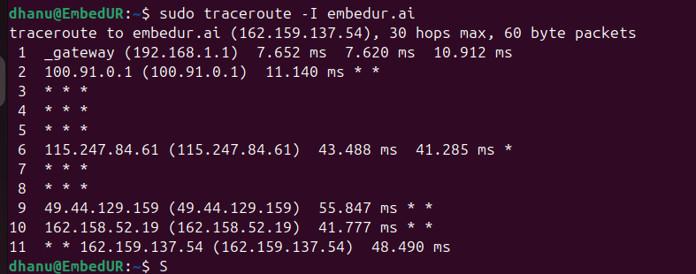

Some commonly used options are

-T to transmit TCP packet

-I to Transmit ICMP packet

-m to change the max hop limit

-n to show only IP not the Domain name

-q number of packet sent per hop